A Project Report o n

“Image Generation Using GAN”

SUBMITTED TO

G H RAISONI COLLEGE OF ENGINEERING AND MANAGEMENT, PUNE

DEPARTMENT OF ARTIFICIAL INTELLIGENCE and

ARTIFICIAL INTELLIGENCE & MACHINE LEARNING

SUBMITTED BY-
NIHAL RANA | AIML-A53
NIHIR BORKAR | AIML-A54
OM MANOJ PAJGADE | AIML-A56

UNDER THE GUIDANCE OF

Prof. Amruta Kulkarni

DEPARTMENT OF ARTIFICIAL INTELLIGENCE AND MACHINE LEARNING

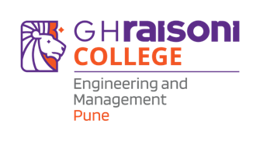

G H RAISONI COLLEGE OF ENGINEERING MANAGEMENT, WAGHOLI, PUNE.
2024-25

CERTIFICATE

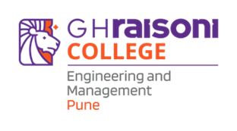

This is to certify that the minor project report entitles

“IMAGE GENERATION USING GAN”

Submitted By
NIHAL RANA | A53
NIHIR BORKAR | A54
OM M. PAJGADE | A56

are the bonafide students of this institute and the work has been carried out by them under the supervision of Prof. Amruta Kulkarni and it is approved for the partial fulfilment of the requirement.

Prof. Amruta Kulkarni Dr. Rachna Sable
Guide Head of Department

Dr. R. D. Kharadkar
Campus Director
GHRCEM, Pune

